A Plan To Protect
God's Children™


Step 1: Know the Warning Signs

Knowing the warning signs means that
we can recognize the early signs of an
inappropriate relationship with a child. If
we know the warning signs, then we can
identify potential abuse before it happens.
If we know the warning signs, we do not
have to rely on a child to report an incident.

- Discourages other adults from
participating or monitoring.

- Always wants to be alone with children.

- More excited to be with children than
adults.

- Gives gifts to children, often without permission.

- Goes overboard touching.

- Always wants to wrestle or tickle.

- Thinks the rules do not apply to them.

- Allows children to engage in activities
their parents would not allow.

- Uses bad language or tells dirty jokes
to children.

- Shows children pornography

Step 2: Control Access

Controlling access means that we are careful about whom we allow to work with our children. It also sends a message to potential child
molesters that we are alert about child
sexual abuse.

- Communicate the church’s commitment to keeping children safe.

- Use written, standard applications.

- Require criminal background checks.

- Complete face-to-face interviews.

- Check references.

Step 3: Monitor all Programs

Child molesters look for ways to spend time alone with children. If they know someone is watching, they have more trouble finding opportunities to abuse without getting caught.

- Identify secluded areas, lock empty rooms.

- Develop policies regarding use of secluded areas. For example, staff should check
bathrooms before sending children in alone.

- Do not permit children to enter staff-only areas.

- Only meet with children where other adults can pass by.

- Supervisors should look in on activities.

- Make sure enough adults are involved
in programs.



- Allow parents to drop in on programs.

- Don’t start new programs without approval
from the pastoral council, the pastor, and/or
the children’s ministry committee.



Step 4: Be Aware

Being aware means that parents should know what is going on in the lives of their own children and
pay attention to subtle signs of a problem. Parents should talk to their children, listen to them, and observe them. When we observe and communicate with our children, we are more likely to detect the signs if they are in danger. We can notice a
sudden change in behavior, if they get moody
or aggressive, lose interest in school, or stop
taking care of their personal hygiene.

- Talk to your children.

- Listen to your children.

- Observe your children.

- Let your children know they can tell
you anything.

- Teach your children where their private
parts are.

- Talk to your children often about
protecting themselves.

- Teach your children what to do if someone
tries to touch them.

- Teach your children what to do if someone makes them uncomfortable.


Step 5: Communicate
Your Concerns

Communicating concerns means
telling someone when you are
uncomfortable with a situation or
if you suspect abuse. It means
paying attention to your own feelings
and not waiting until it is too late.

Only by communicating concerns can
we use our knowledge to protect children.
Even if abuse is not occurring, it is still
important to let others know when you
have concerns.

- Talk to the person involved, and/ or 

- Speak to their supervisor, and/or

- Notify a church official, and/or

- Call the child abuse hotline, and/or

- Call the police.

VIRTUS® is registered trademark of The National Catholic Risk Retention Group, Inc. (“National Catholic”) in the United States. Protecting God’s Children™ and A Plan to Protect God’s Children™ are trademarks of National Catholic. National Catholic has licensed use of its Protecting God’s Children™ programs to the Diocese of Bridgeport (“Diocese”). National Catholic owns the copyrights in the artwork and substantive text appearing in this brochure. In addition, National Catholic has authorized the Diocese to distribute the artwork and text in this brochure to employees and volunteers of the Diocese. Neither the artwork nor text may be reproduced or further distributed in any form or manner, without the prior written permission of National Catholic. Please feel free to contact National Catholic for more information about its products and services. You may contact:

Michael Bemi
The National Catholic Risk Retention Group, Inc.
801 Warrenville Road
Suite 175 Lisle, IL 60532
1-877-486-2774

©2002-2003 by The National Catholic Risk Retention Group, Inc. All rights reserved.

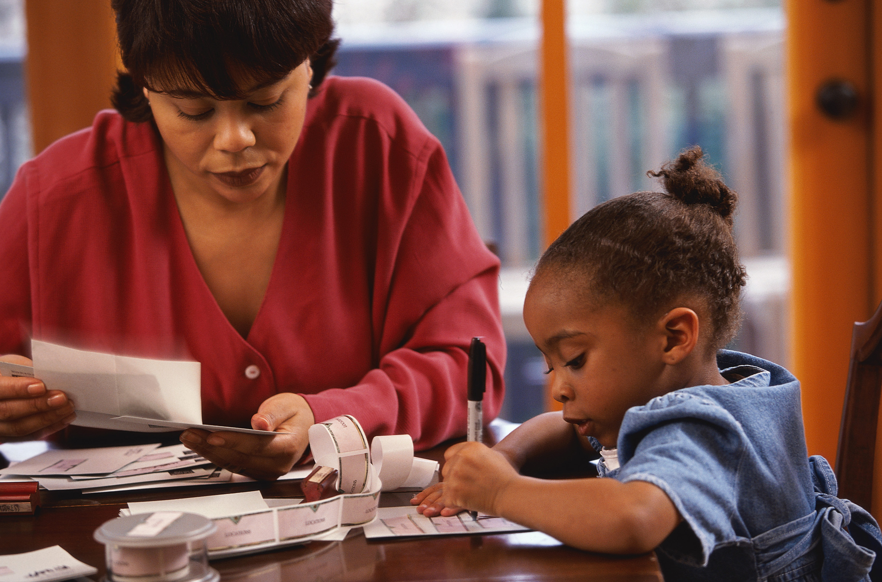

To report abuse in Connecticut

If you suspect a child is in imminent danger from abuse, please call 911 immediately.
To report suspected child abuse, contact:
The CT Department of Children and Families
1-800-842-2228
Erin Neil LCSW : Victim Assistance Coordinator & Director of Safe Environments: (203) 416-1406 eneil@diobpt.org Cell: (203) 650-3265

The Diocese of Bridgeport



National Catholic Risk Retention Group, Inc.

Protecting
God’s
Children™

Quick Reference Guide



